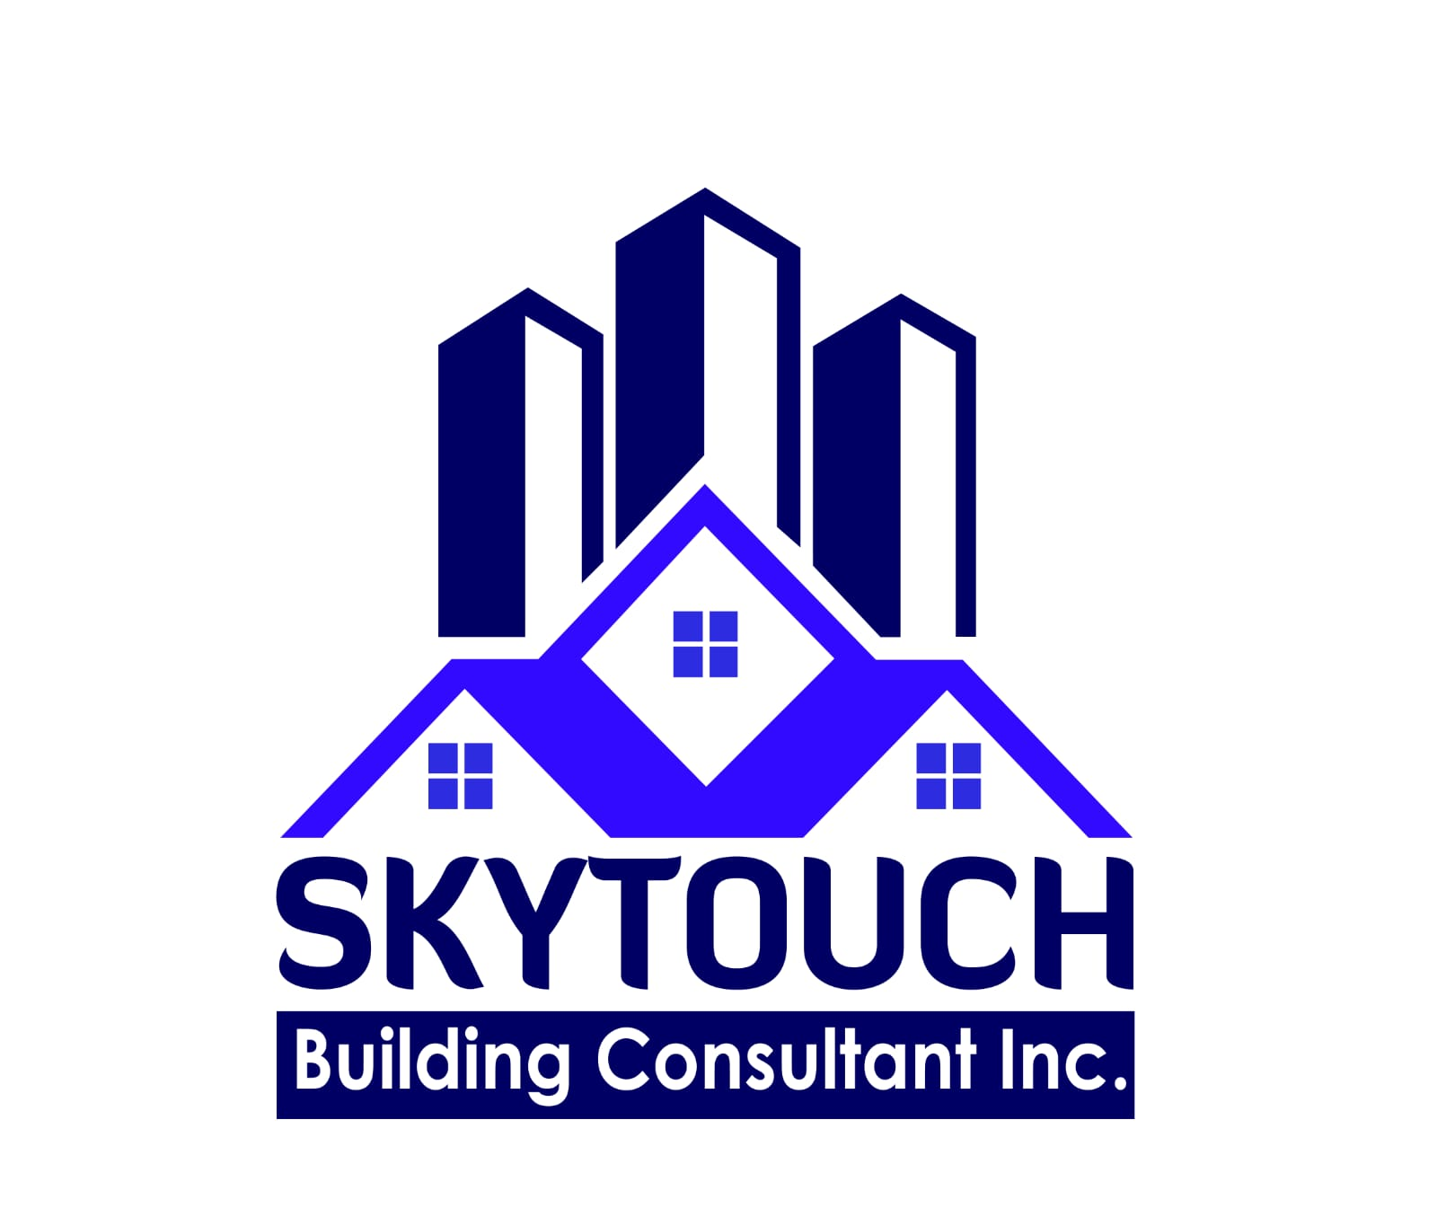
200-1071 Midland Ave., Toronto, ON, M1K 4G7
PROPERTY MANAGEMENT AGREEMENT
This Property Management Agreement (this “Agreement”) is made this _____ day of _______________, 20____, and is entered into by and between:
The Owner(s)
Name: _______________________________________________
Address: _____________________________________________
Contact Information: __________________________________
(hereinafter referred to as the “Owner”)
- AND -
The Property Manager: Skytouch Building Consultant Inc.
Address: 200-1071 Midland Ave., Toronto, ON, M1K 4G7
(hereinafter referred to as “Skytouch” or the “Property Manager”)
(the Owner and Skytouch are each a “Party” and collectively the “Parties”)

1. The Property
This Agreement applies to the property municipally known as ___________________________________________________ (the “Property”), including the residential structure (if any), all fixtures and appliances, and all grounds, lawn, gardens, driveways, and exterior areas forming part of the Property.

2. Appointment and Term
The Owner hereby appoints Skytouch as the exclusive agent to manage, maintain, and look after the Property on the Owner's behalf, and Skytouch accepts this appointment on the terms set out in this Agreement. This Agreement shall commence on _______________, 20____, and shall continue until terminated by either Party upon at least thirty (30) days' prior written notice, delivered by a verifiable method such as registered mail or email with read receipt.

3. Services Provided by Skytouch
Skytouch agrees to provide the following services with reasonable skill and care, and strictly as agent for, and at the cost of, the Owner:

3.1 Marketing and Leasing (where applicable)
- Conduct market analysis to determine a competitive rental rate.
- Market and advertise the Property on MLS and other appropriate platforms.
- Screen and select qualified tenants, including background, credit, and reference checks.
- Prepare and execute legally compliant lease agreements on behalf of the Owner.

3.2 Rent and Financial Management
- Collect all rents, security deposits, and other applicable fees from tenants, and hold such funds in trust in compliance with Ontario regulations.
- Provide the Owner with detailed monthly financial statements showing all income and expenses.
- Remit net rental income to the Owner's specified bank account by the _____ day of each month.

3.3 Maintenance and Repairs
- Coordinate and oversee all necessary maintenance, repairs, and capital improvements to the Property.
- Obtain prior written approval from the Owner for any single repair or expense exceeding $500, except in an emergency that threatens the Property or tenant safety.
- Arrange emergency repairs up to $1,500 without prior approval where required to protect the Property or tenant welfare.

3.4 Grounds-Keeping, Lawn Care and Landscaping Maintenance
- Skytouch will arrange, coordinate, or directly perform routine grounds-keeping for the Property, including lawn mowing, garden landscaping, seasonal yard clean-up, snow removal (where applicable), and general exterior maintenance, as reasonably required to preserve the condition and appearance of the Property.
- All costs of lawn mowing, garden landscaping, and related grounds maintenance are the sole financial responsibility of the Owner and will be charged to the Owner in accordance with Section 5 (Management Fee and Expenses) below, whether performed by Skytouch directly or by a third-party contractor engaged by Skytouch on the Owner's behalf.
- Skytouch will use reasonable efforts to engage licensed and insured contractors for any grounds or landscaping work and will provide the Owner with an itemized invoice for such services.

3.5 Tenant and Property Management
- Act as the primary point of contact for tenant inquiries and issues, where the Property is tenanted.
- Conduct move-in, move-out, and periodic inspections to confirm lease compliance and identify maintenance needs.
- Ensure the management of the Property complies with the Residential Tenancies Act, 2006 (Ontario) and all other applicable federal, provincial, and municipal laws.

3.6 Reporting
- Provide the Owner with a monthly report summarizing rental income (if any), expenses, grounds and maintenance activity, and any outstanding matters.

4. Owner's Responsibilities
The Owner agrees to:
- Provide Information: Furnish Skytouch with all documentation reasonably required to manage the Property, including deeds, tax information, survey or boundary details, and any existing leases.
- Maintain Insurance: Secure and maintain comprehensive insurance for the Property, including general liability and property damage insurance, and name Skytouch as an additional insured on the policy.
- Fund Repairs and Maintenance: Provide timely funds for repairs, capital improvements, and grounds/landscaping maintenance not covered by rental income, and pay all invoices issued under Section 3.4 within the timeframe set out in Section 5.
- Liability: Acknowledge that, as between the Parties, the Owner remains ultimately responsible for all legal, financial, and safety obligations arising from the Property, its condition, its tenants (if any), and its grounds, except where a matter results directly from Skytouch's own gross negligence or willful misconduct as set out in Section 7.

5. Management Fee and Expenses
- Management Fee: The Owner agrees to pay Skytouch a fee of ____% of monthly gross rental income collected, where the Property is tenanted. Skytouch may deduct this fee directly from rental income.
- Grounds, Lawn Care and Landscaping Charges: The Owner shall be solely responsible for, and shall reimburse or pay Skytouch for, all costs of lawn mowing, garden landscaping, seasonal clean-up, and other grounds maintenance performed on or for the Property under Section 3.4. Such charges will be itemized and invoiced to the Owner monthly and are due within fifteen (15) days of invoice, or may be deducted from rental income where available.
- Additional Fees: Services outside the scope of this Agreement, such as major renovation coordination or legal proceedings, will incur separate fees as agreed in writing between the Parties.
- Authorized Expenses: Skytouch is authorized to deduct all approved and reasonable expenses from rental income (where applicable), including advertising costs, repair invoices, grounds-maintenance invoices, and utility payments.

6. Termination
Either Party may terminate this Agreement upon thirty (30) days' written notice. Upon termination:
- Skytouch will provide a full accounting and transfer all funds held in trust to the Owner within thirty (30) days.
- Skytouch will provide the Owner with all relevant property documents, including tenant files, lease agreements, and maintenance and grounds-service records.
- The Owner agrees to pay all outstanding fees, expenses, and grounds-maintenance invoices owed to Skytouch up to the date of termination.

7. Indemnification and Limitation of Liability
- No Liability to Skytouch: Skytouch manages and looks after the Property strictly as agent for the Owner and assumes no liability whatsoever for the condition of the Property, injuries or damages occurring on or about the Property, the acts or omissions of tenants, contractors, or grounds/landscaping personnel, or any other matter arising from the management or maintenance of the Property, except where such liability arises directly from Skytouch's own gross negligence or willful misconduct.
- Owner's Indemnification: The Owner agrees to indemnify and hold harmless Skytouch, its directors, officers, employees, and subcontractors from any and all claims, liabilities, damages, or expenses arising from the Property, its operations, its grounds and landscaping, or any breach of this Agreement by the Owner, except where such claims arise from Skytouch's own gross negligence or willful misconduct.
- Independent Contractors: Any lawn care, landscaping, or maintenance work performed by third-party contractors engaged by Skytouch is performed on behalf of, and at the cost of, the Owner. Skytouch's responsibility is limited to the reasonable selection and oversight of such contractors, and Skytouch assumes no liability for the quality, safety, or outcome of their work.
- Limitation of Liability for Rent Default: Skytouch is not responsible for any tenant's default, delay, or failure to make rent payments. The risk of rent default remains solely with the Owner, and Skytouch provides no guarantee of payment.
- Force Majeure: Neither Party is liable for failure or delay in performance due to events beyond its reasonable control, including acts of God, war, and natural disasters.

8. Dispute Resolution
Any dispute arising from this Agreement shall first be addressed through good-faith negotiation between the Parties. If unresolved within thirty (30) days, the Parties agree to pursue mediation with a mutually agreed mediator before resorting to litigation. Mediation costs shall be shared equally between the Parties.

9. Governing Law, Regulatory Compliance, and Entire Agreement
- This Agreement is governed by and construed in accordance with the laws of the Province of Ontario and the federal laws of Canada applicable therein.
- Skytouch shall perform its services in compliance with the Residential Tenancies Act, 2006 (Ontario), applicable municipal property standards and grounds-maintenance by-laws, the Occupational Health and Safety Act (Ontario) as it applies to any personnel or contractors retained, and all other applicable federal, provincial, and municipal laws and regulations governing residential property management and grounds maintenance in Canada.
- This Agreement constitutes the entire understanding between the Parties and supersedes all prior agreements, discussions, and understandings, whether written or oral. No amendment or modification is valid unless made in writing and signed by both Parties.

Signatures
By signing below, the Parties acknowledge that they have read, understood, and agree to be bound by the terms of this Agreement.

Owner(s)
Signature: ___________________________________
Print Name: ___________________________________
Date: ___________________________________

Skytouch Building Consultant Inc.
Signature: ___________________________________
Print Name / Title: Authorized Representative
Date: ___________________________________

Note: G & J Trading Inc. is an affiliated Ontario-based organization with Skytouch Building Consultant Inc.

